RESQAI: AI-BASED ACCIDENT DETECTION, SEVERITY ASSESSMENT AND INTELLIGENT EMERGENCY RESPONSE SYSTEM
Scope and Limitations
Department of Computer Science and Engineering, TKR College of Engineering & Technology
Batch A2 (CSE-A) · Academic year [ACADEMIC YEAR]
Table 1: Project team
S.No. | Student name | Roll number
1 | Adepu Meenakshi | 23K91A0503
2 | Ayila Shanmukha Sai | 23K91A0521
3 | Chekka Chandrashekhar | 23K91A0552
4 | Avula Sreeya | 23K91A0519

Project guide: Shirisha Reddy
Chapter and section numbers quoted in the text (for example Chapter 8 or Section 6.2) refer to the full project report, 17.Final Document. Figures and tables in this document are numbered from 1.

1. SCOPE

1.1 In scope
• Crash detection from motion features. Eleven features (three acceleration axes and their magnitude, three rotation axes and their magnitude, speed before the event, speed change, jerk) classified as accident or not.
• Severity grading into None, Minor, Moderate and Severe, evaluated per class.
• Occupant confirmation with a 15-second countdown, cancel by button or Escape, and automatic dispatch when the time runs out.
• Location and hospital recommendation from the browser's position, with a ten-hospital directory around Hyderabad, ranked by great-circle distance.
• Dispatch message and emergency dashboard: alert id, severity, confidence, map link, nearest hospital and phone, three nearest hospitals on a Leaflet map, call buttons for 108, 112 and 103.
• A web console and API: landing page, registration and sign-in, live monitor, manual override, response map, light and dark themes, optional token guard for the API.
• Evaluation by accuracy, precision, recall and F1, five-seed repeat, baselines, ablation, noise and threshold analysis, API latency, and tests.

1.2 Out of scope
• A phone application. There is no Android or iOS code and no streaming of real sensor data; a built-in simulator stands in for the phone.
• Real crash or road data. No smartphone recordings, crash-test data or public benchmark were used or collected.
• Delivery of the alert. No SMS, voice call, e-mail or push notification is sent, no contact list is stored and no responder acknowledges.
• Road-surface events. Potholes, speed breakers, phone drops and similar events are not part of the training data.
• Routing and hospital capability. No road network, traffic, ambulance dispatch, specialty or bed information; the nearest hospital is the nearest by straight line.
• Post-crash analytics of the kind done by the base paper (injury counts, property loss, SHAP at class level).
• Vehicle integration (airbag, OBD-II, in-vehicle crash sensors) and multi-vehicle or roll-over modelling.
• Production operation: HTTPS, load balancing, monitoring, data-protection compliance and regulatory approval of an automatic emergency call.

1.3 Target users
The system is aimed at the occupant of a car or two-wheeler who carries a smartphone, and at a responder who would receive the message. In this build only the occupant's console exists; the responder's side is represented by the drafted message and the map.

2. ASSUMPTIONS
The design and the measurements rest on the following assumptions. Where one fails in practice, the corresponding result in Chapter 8 should be read with care.
• The phone is rigidly attached and its orientation is known. The generator draws an acceleration vector in a random direction in the horizontal plane and keeps gravity on the z axis; a phone in a pocket or a loose mount would blur this.
• Crash events look like the generator. A crash is a large, brief spike of acceleration and rotation together with a drop in speed and a high jerk; real crashes include low-speed scrapes, rear-end hits and roll-overs that this description does not capture.
• Non-crash events are normal driving or hard braking. Potholes, speed breakers, kerb strikes and drops of the phone are assumed absent, which is untrue on real roads.
• The sensor is noiseless apart from the generator's own spread. Real accelerometers add bias, drift and vibration (Section 8.6 of the report shows the effect of noise).
• A smartphone can compute the eleven features and send them as JSON (speed from GPS or the vehicle, jerk from the derivative of acceleration) in time to act.
• The occupant sees and hears the prompt. The 15-second countdown assumes a screen or sound that a conscious occupant can notice and answer; an incapacitated occupant is meant not to answer.
• The browser position is usable. Geolocation permission is granted; if not, a point near the default location in Hyderabad is used instead, which is only a demonstration fallback.
• The ten hospitals are all suitable. The directory carries no specialty, capacity or availability.
• One user, one machine. The measurements were taken on one Windows 11 computer with a single client; the pickles written by scikit-learn 1.9.0 are assumed to load identically under the installed version (verified here for 2,400 events).

3. LIMITATIONS

Data
The single largest limitation is the data. All 12,000 events are synthetic; the test events come from the generator that produced the training events, and the crash classes are separated from normal driving by a gap in acceleration magnitude (harsh braking reaches at most 13.18 m/s2, the weakest crash starts at 15.3 m/s2). Scores of 1.0000 for the detector follow from this and say nothing about roads. The class sizes are also small for the rare grades: the test split has 156 Moderate and 88 Severe events, so one more or fewer error moves the per-class recall by about one percentage point.

Models
• Potholes and speed breakers. The detector flags 49% of pothole-like and 50% of speed-breaker-like probe events as accidents; none reaches the countdown, but the 'Accident detected' log entry is false.
• Sensor noise. The false-alarm rate rises to 1.2% at a quarter and 24.2% at a half of the natural spread; the models were not trained on noise.
• No uncertainty beyond the forest's own probability, which saturates at 0 or 1 for almost every event, so the confidence value shown to the user carries little information.
• No calibration, no sequence model. Each reading is classified alone; there is no window of readings and no use of the temporal shape of a crash.
• Large values are not recognised as absurd. A reading of 1e9 m/s2 is graded Minor instead of being rejected.

Application
• Nothing is sent. The alert is a message on the screen; the ambulance and emergency numbers are tel: links.
• Eight input-validation gaps (four HTTP 500 responses, three accepted nonsense inputs, one repeated alert id) found by scripts/run_tests.py and left unfixed.
• Alerts are not stored and carry no user id, so there is no audit trail and no alert history.
• Development server and file storage. Flask's debug server, accounts in a JSON file, a lock-out counter in the memory of one process, 12-hour tokens without revocation, no HTTPS.
• Hospital directory of ten entries in one city; outside it, the nearest hospital is far away, and inside it, the nearest may be unsuitable (a children's hospital is the second nearest to the demonstration position).
• The pickles come from a newer scikit-learn (1.9.0) than the one installed here (1.5.0); requirements.txt is not pinned. Predictions were verified identical to a fresh retraining, but a pinned environment would be safer.

Hardware and environment
The work was done on one Intel Core i5-12500 computer without a GPU, with 15.7 GB of RAM that other programs were also using. No phone, no sensor board and no vehicle was used, so battery use, sampling rate, background execution limits of a mobile operating system and real GPS error are all unknown.
Two figures show the limitations that matter most for reading the numbers. The first shows why detection is easy on the synthetic data: the crash events and the non-crash events are separated by a gap in acceleration magnitude, so a single threshold detects them as well as the random forest. The second shows how the detector behaves on road-surface events it never saw: about half of the pothole-like and speed-breaker-like probe events are flagged as an accident, although none reaches the Moderate or Severe grade that starts the alert.
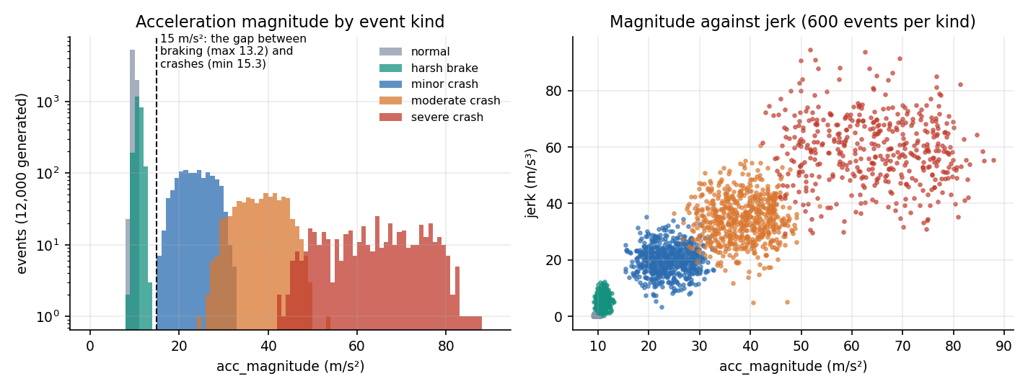
Figure 1: Acceleration magnitude and jerk by event kind in the generated data: crash and non-crash events do not overlap.
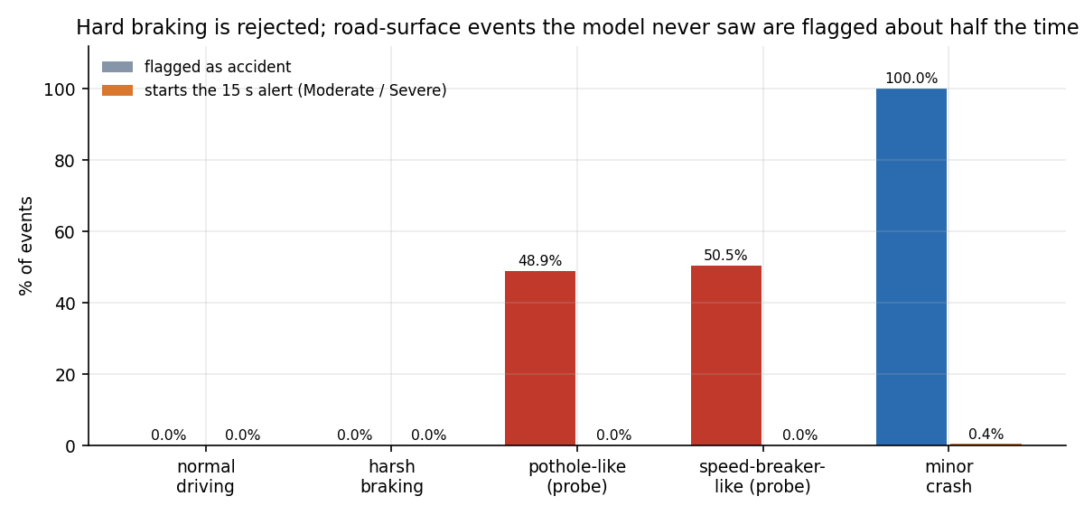
Figure 2: Hard braking is rejected, but road-surface probe events the model never saw are flagged as accidents about half the time.

4. WHAT WAS NOT MEASURED
The following were not measured, and no figure in this report should be read as covering them.
• The detection rate and the false-alarm rate on real crashes and on real everyday driving.
• Behaviour with real phone sensors: mounting, orientation, sampling rate, bias, vibration.
• Pothole, speed-breaker, drop and kerb events from real roads (only a constructed probe was run).
• GPS accuracy and the time to obtain a fix; the position in the screenshots was supplied by the browser.
• Delivery latency of a real SMS, call or e-mail, and the time until a human responds; the 56 ms alert-path figure covers computing only and excludes the 15-second confirmation window.
• Concurrency, endurance and load (more than one client, hours of live monitoring).
• Battery, CPU and memory use on a phone.
• User behaviour: how quickly and reliably occupants cancel, how often they press the button by mistake, whether 15 seconds is the right window; no user study was carried out.
• Accessibility and usability beyond the labels and keyboard handling visible in the code.
• Security under attack: no penetration test, no rate limiting beyond the login lock-out, no analysis of token theft.
• Other platforms: all runs were on Windows 11 with Python 3.11.

